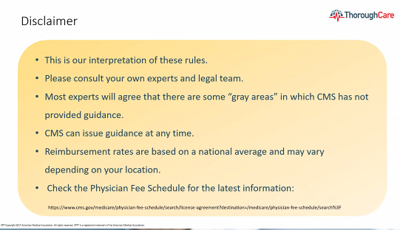

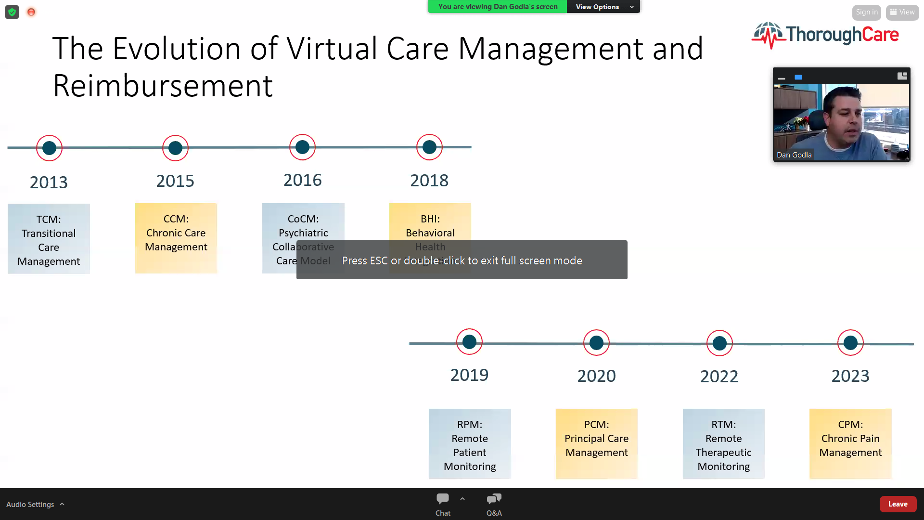

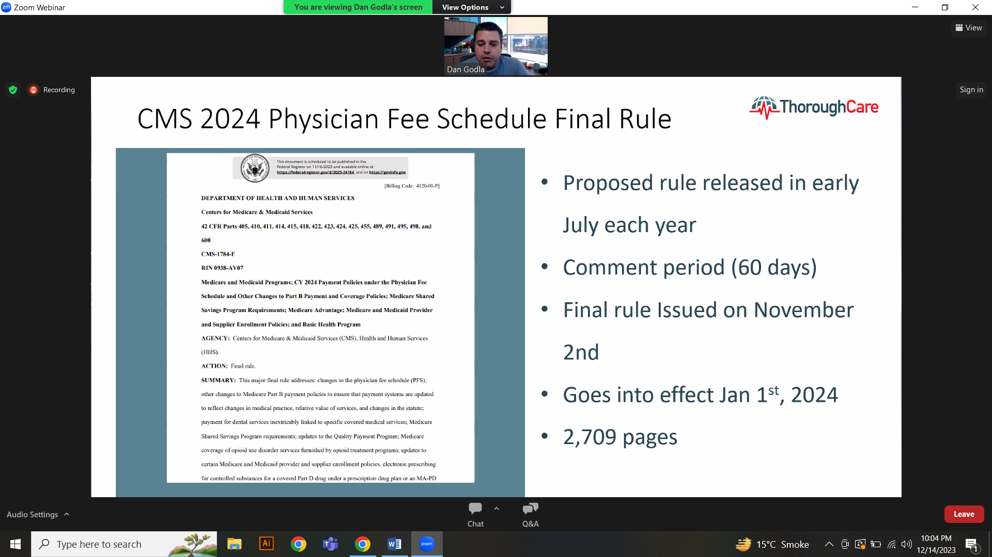

# chrome-extension://efaidnbmnnnibpcajpcglclefindmkaj/https://public-inspection.federalregister.gov/2023-24184.pdf

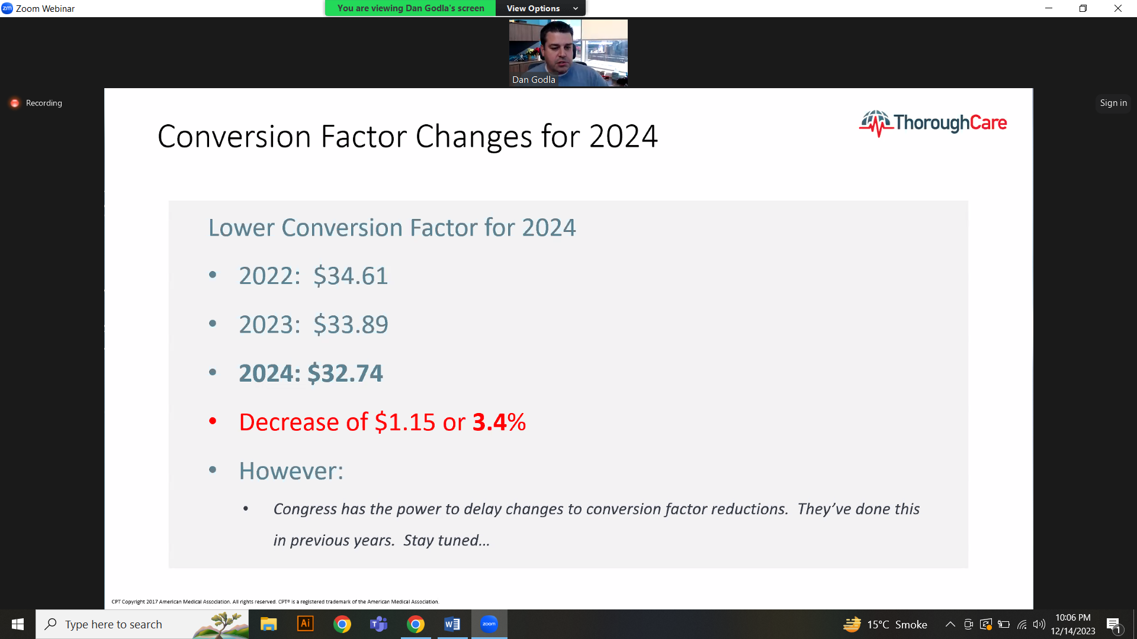

Conversion factor is going down this year, this means decrease of 3.4% of conversion factor

Assume that raise will be lower

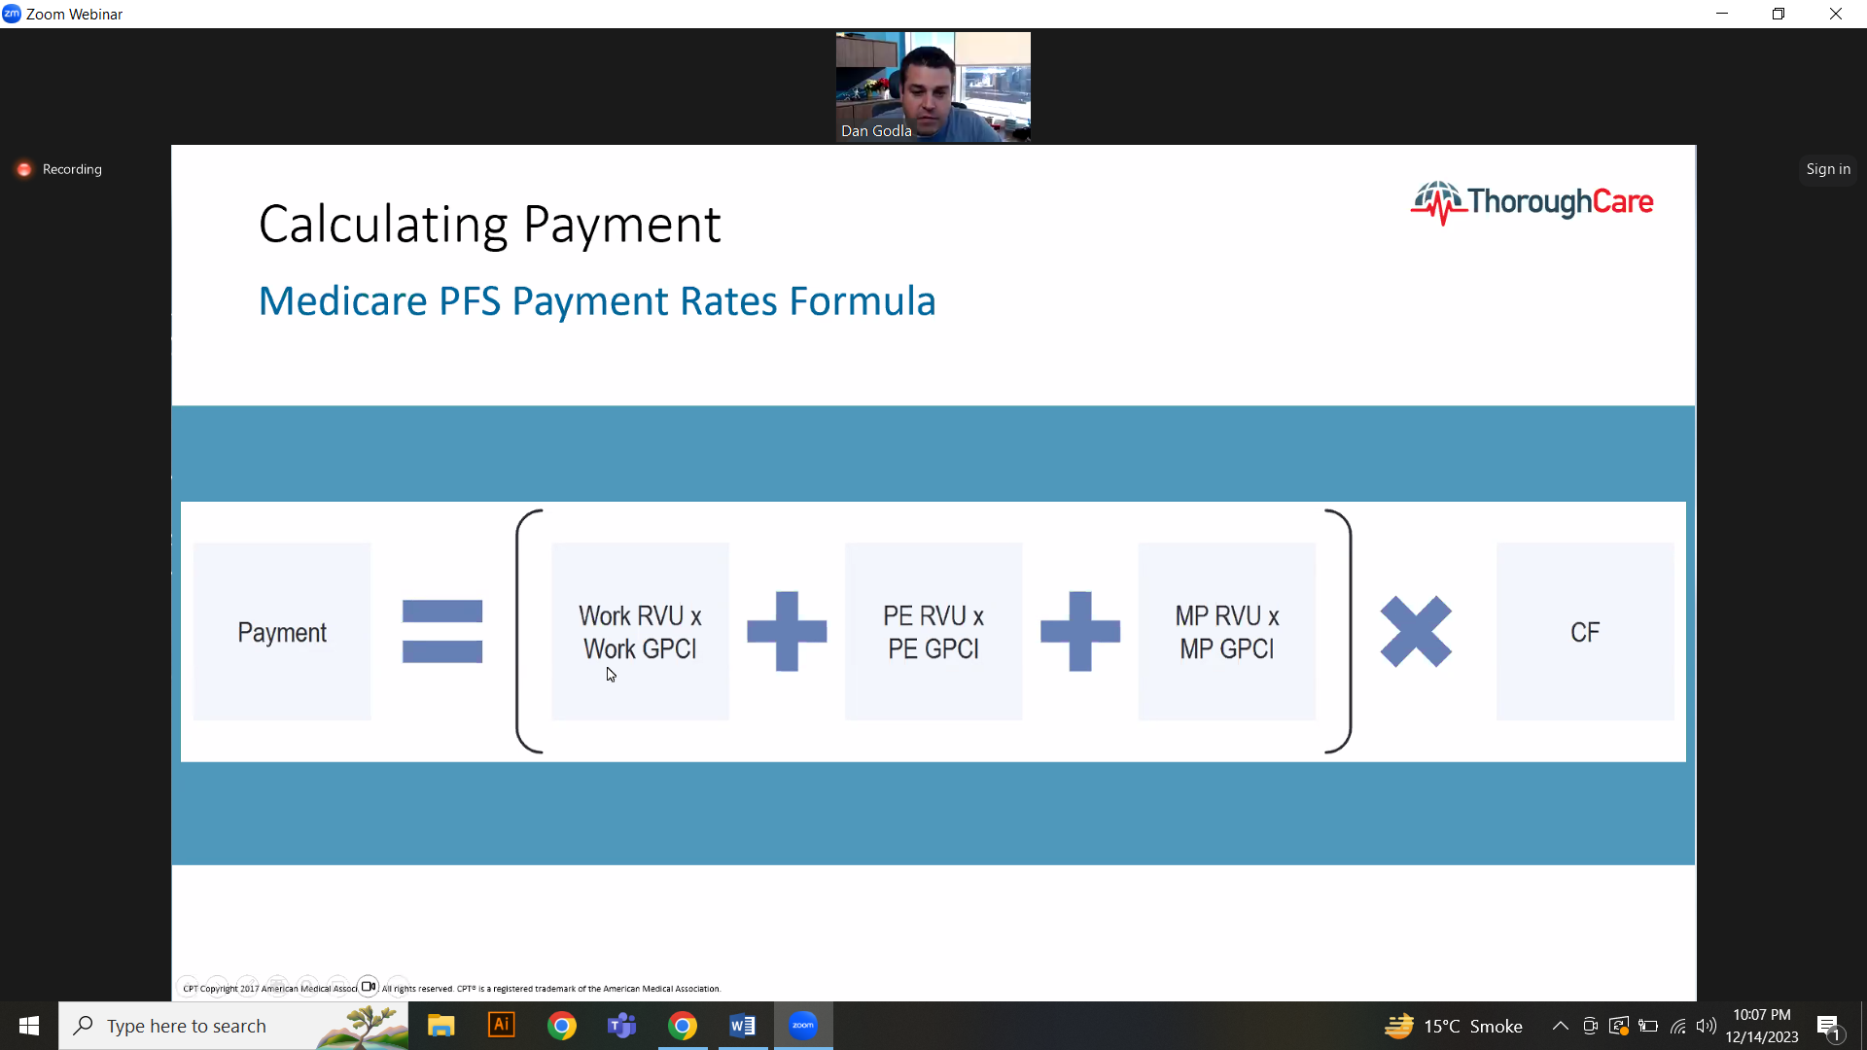

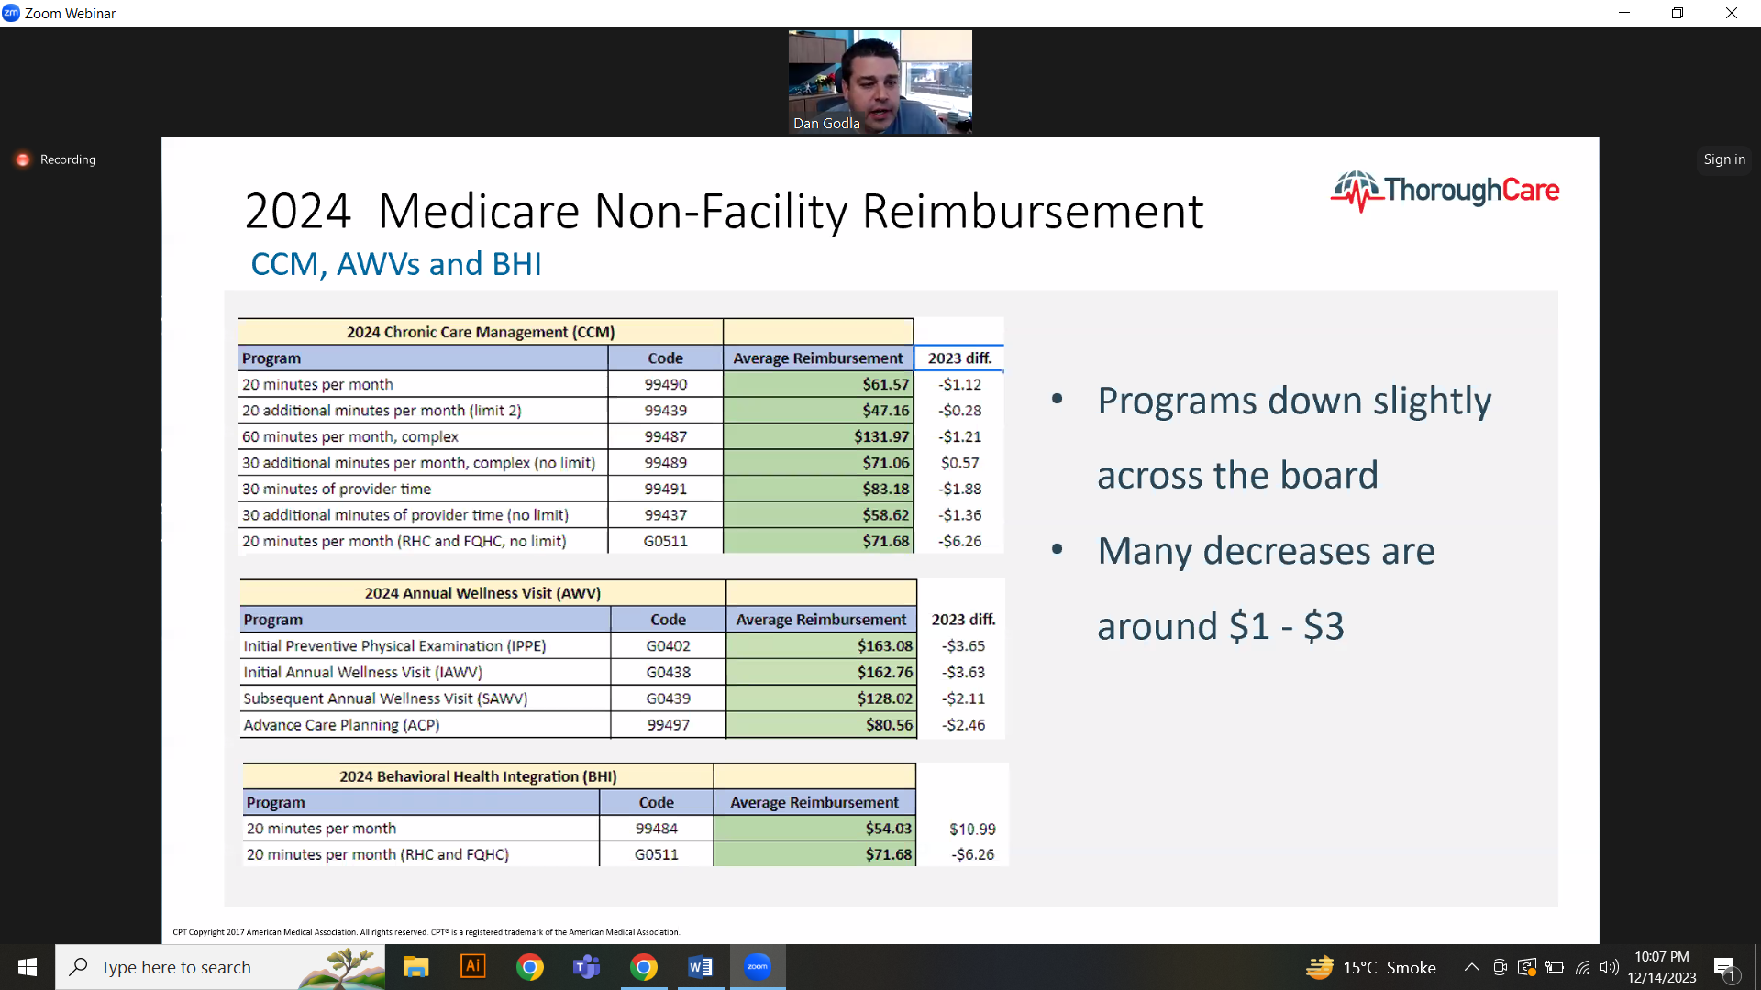

What chronic care management looks like

Small decrease but something you should be aware of if you are doing this programs

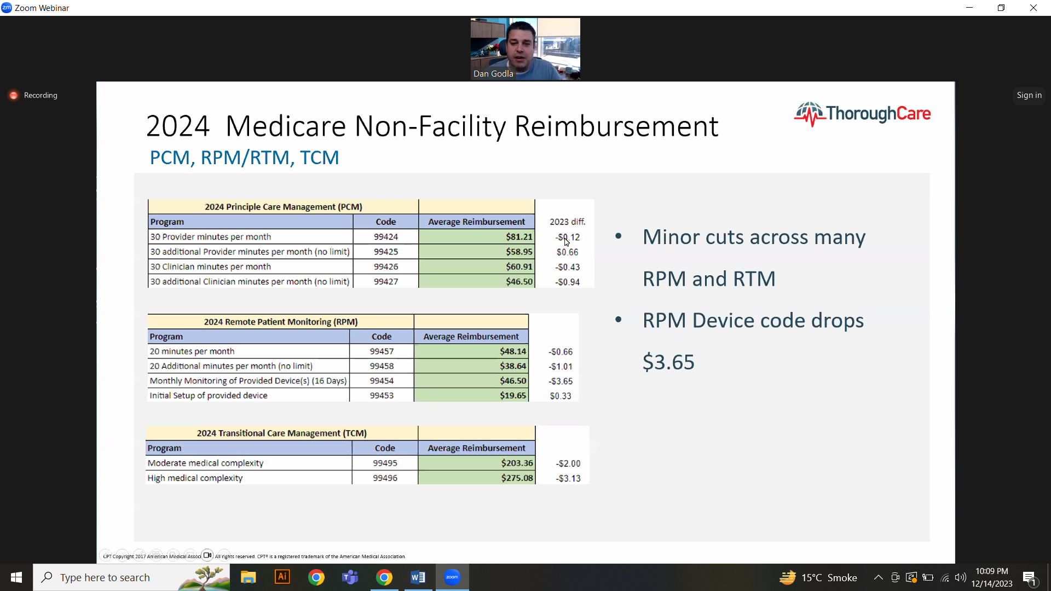

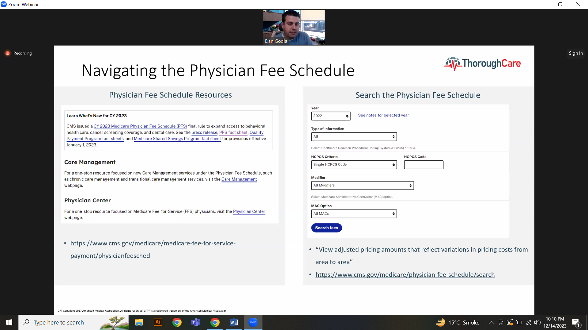

<https://www.cms.gov/medicare/physician-fee-schedule/search/license-agreement?destination=/medicare/physician-fee-schedule/search%3F>

2024 not available yet

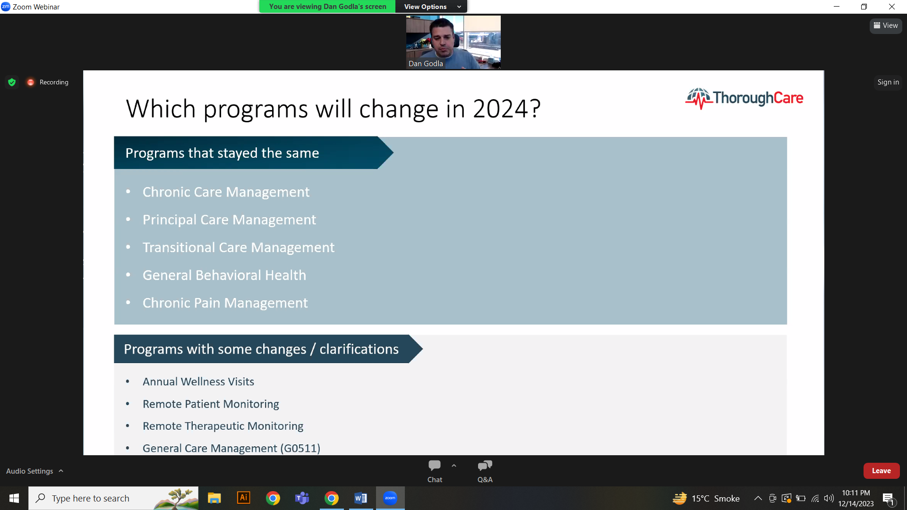

New programs creates;

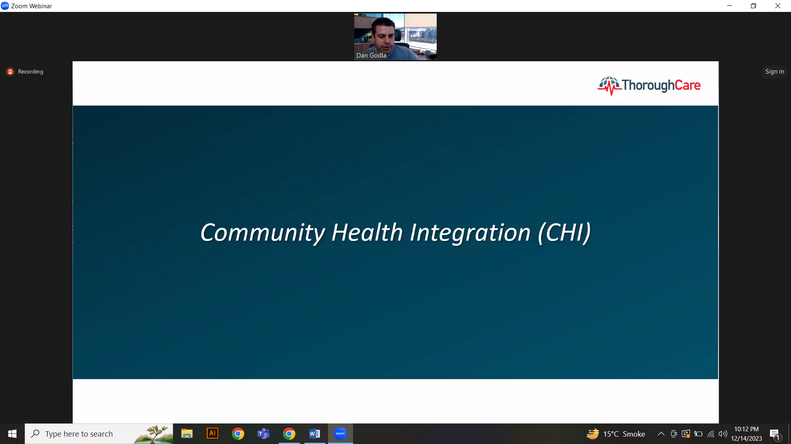

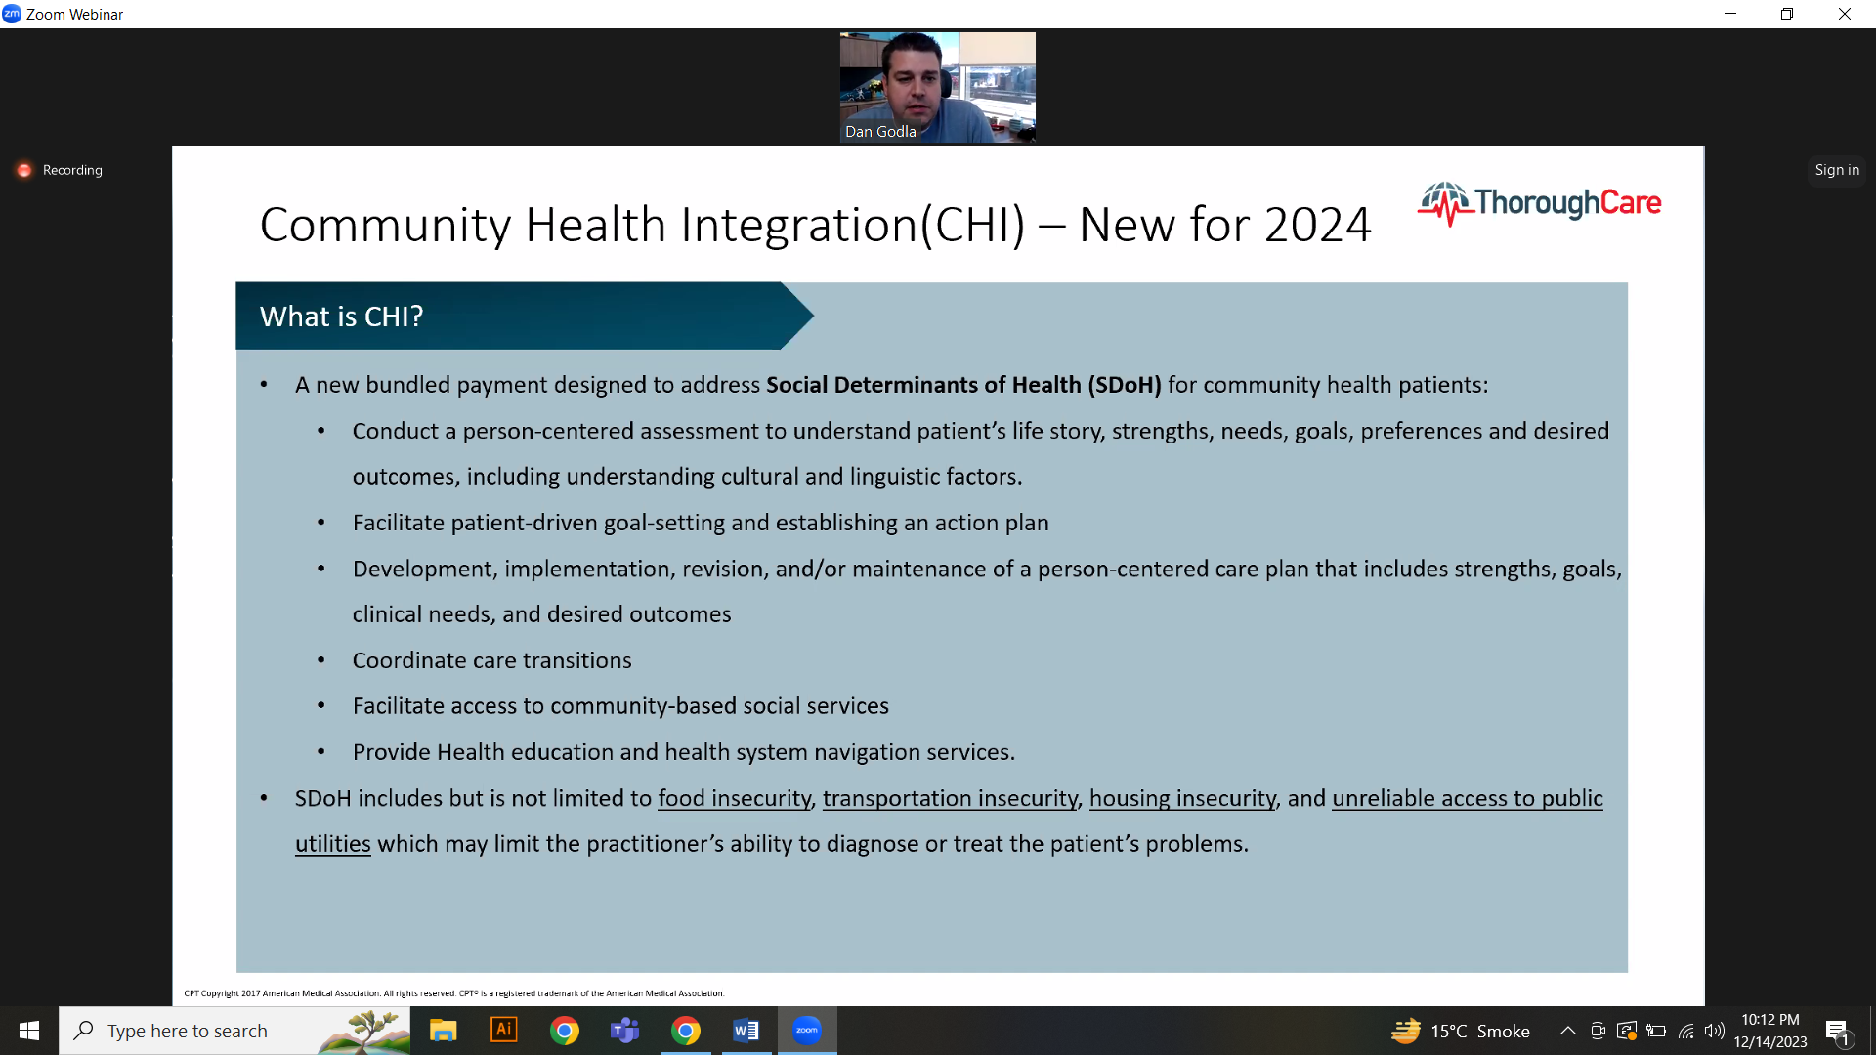

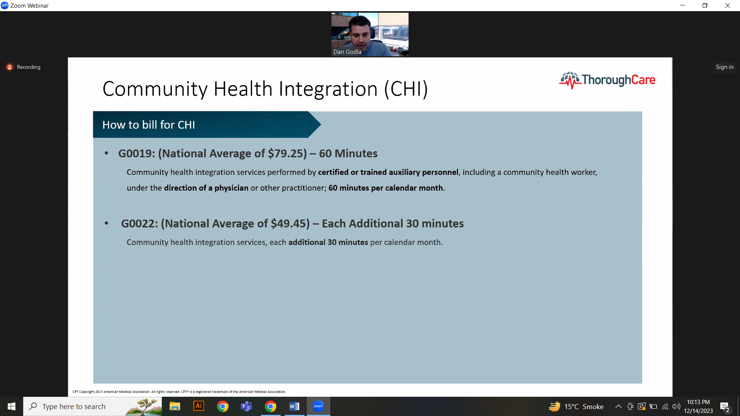

No limit indicated

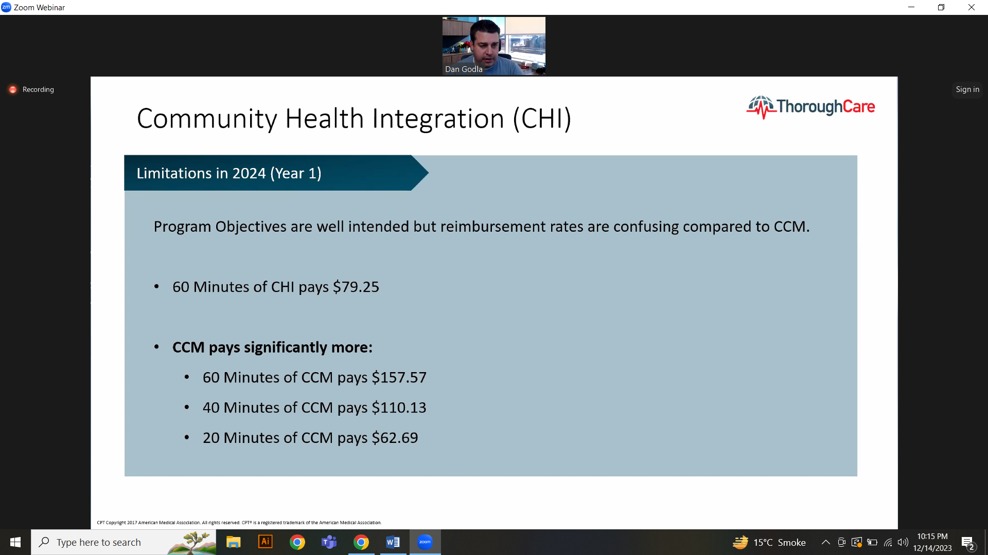

CCM pays more, if you are spending same 60 minutes you are getting more dollars for CCM. CHI only benefit is addressing social barriers limiting their care.

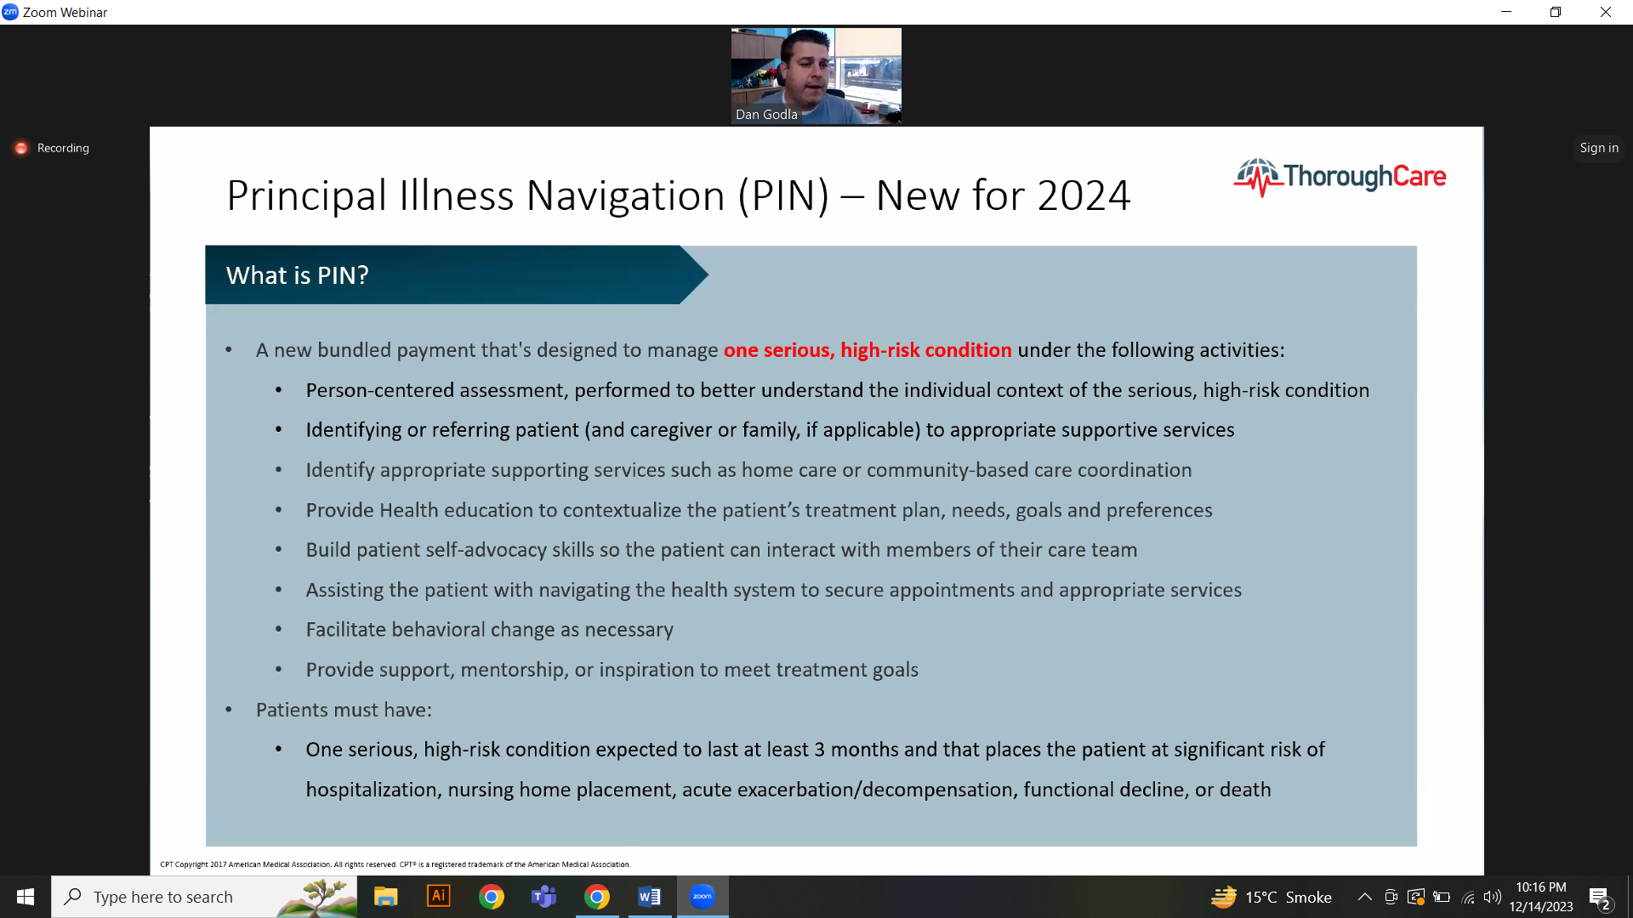

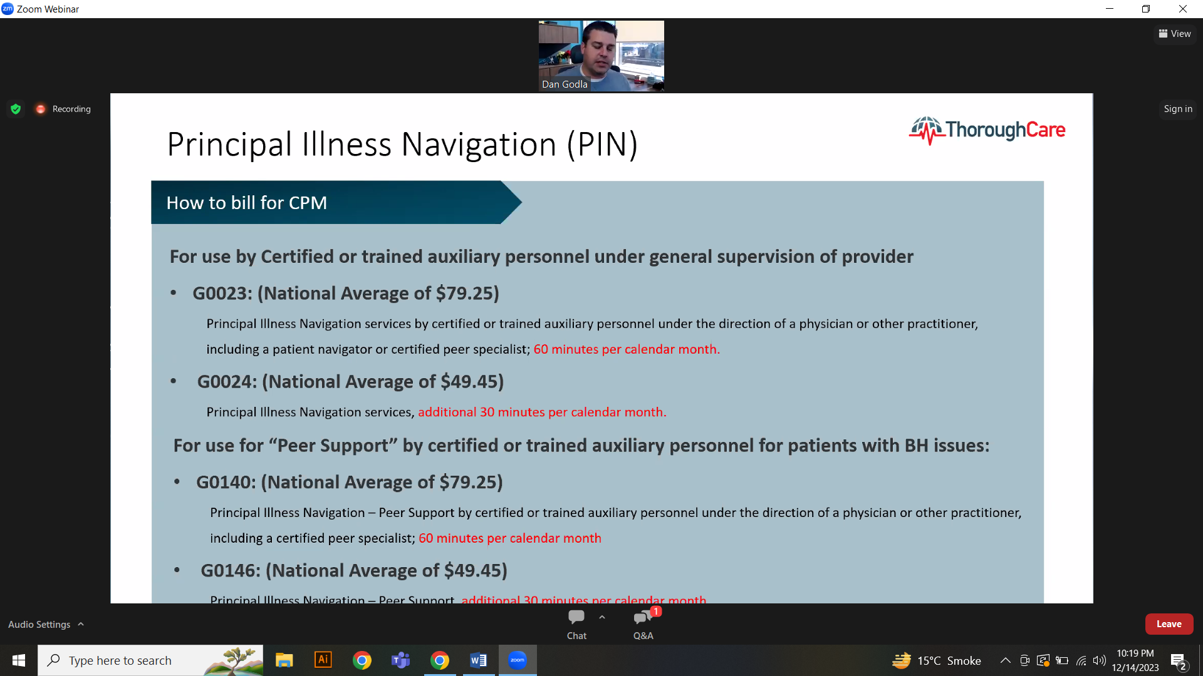

Trend is programs get better overtime, CMS whenever releases new programs

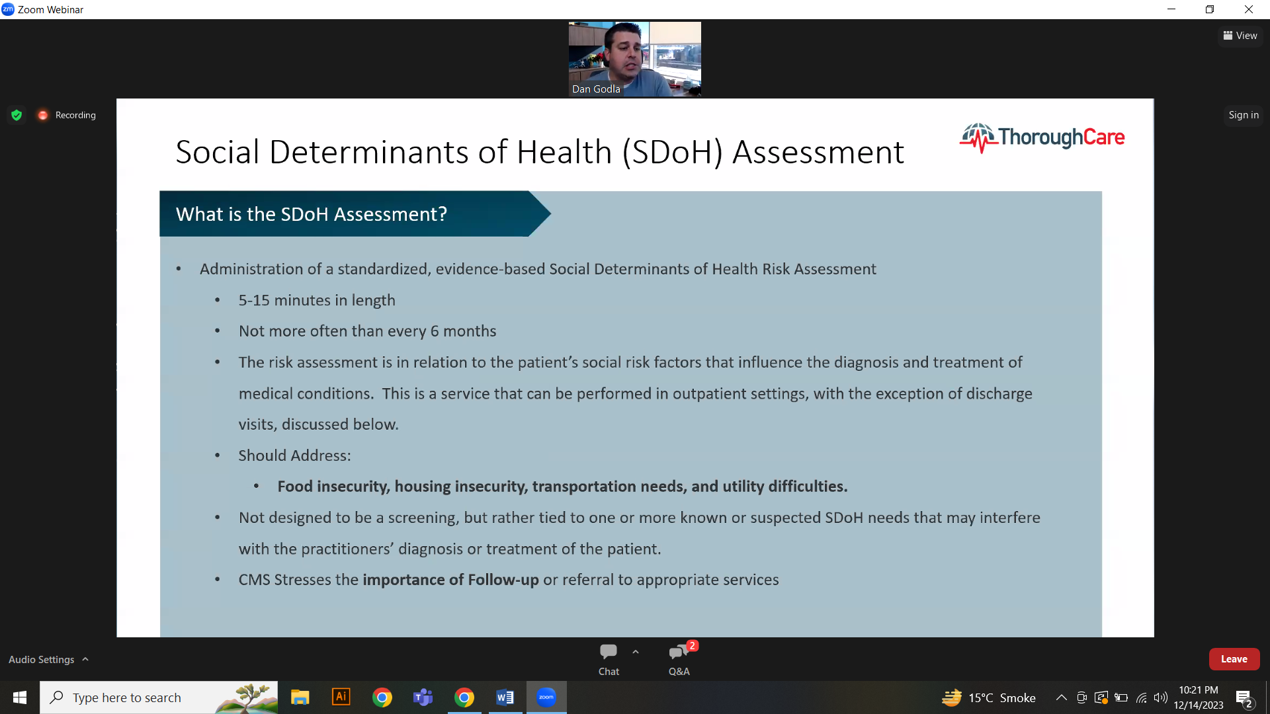

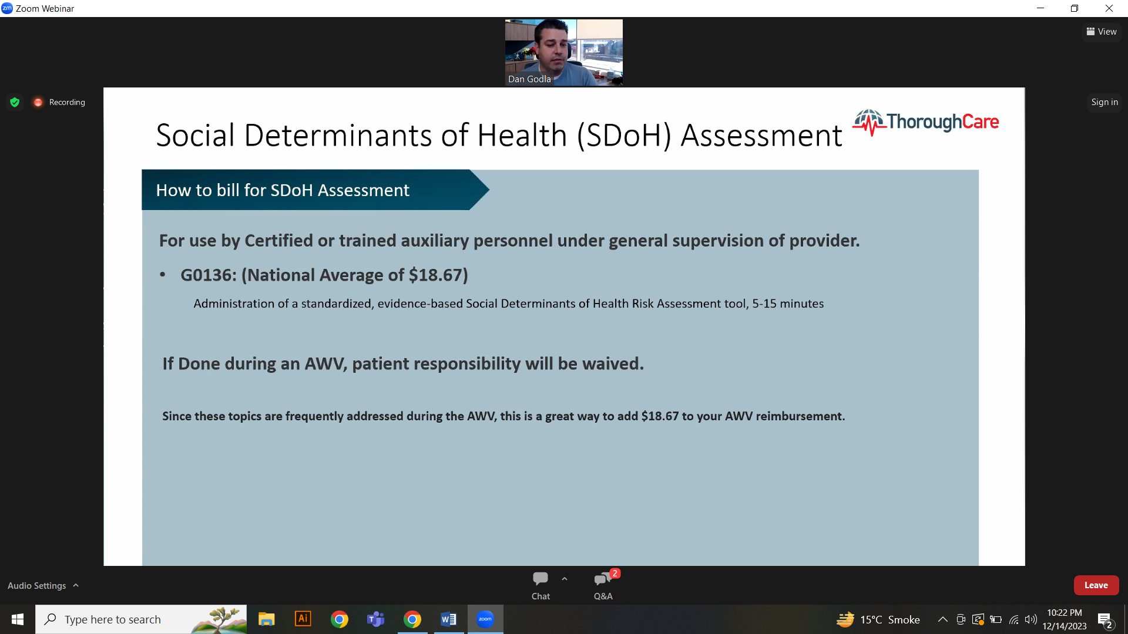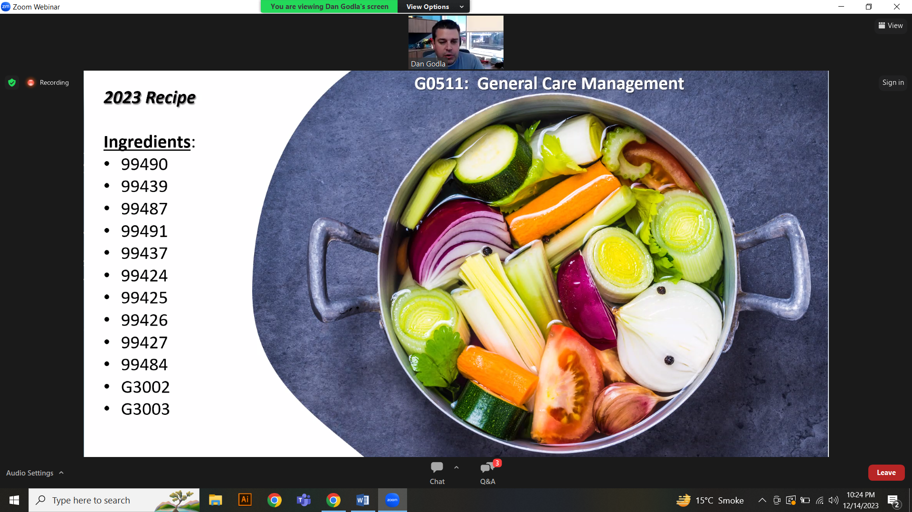

The challenge has been, this code is limited to one instance well that is changing is for 2024. Now multiple serving as well

NO need to stop after 20 minutes if you need to go on

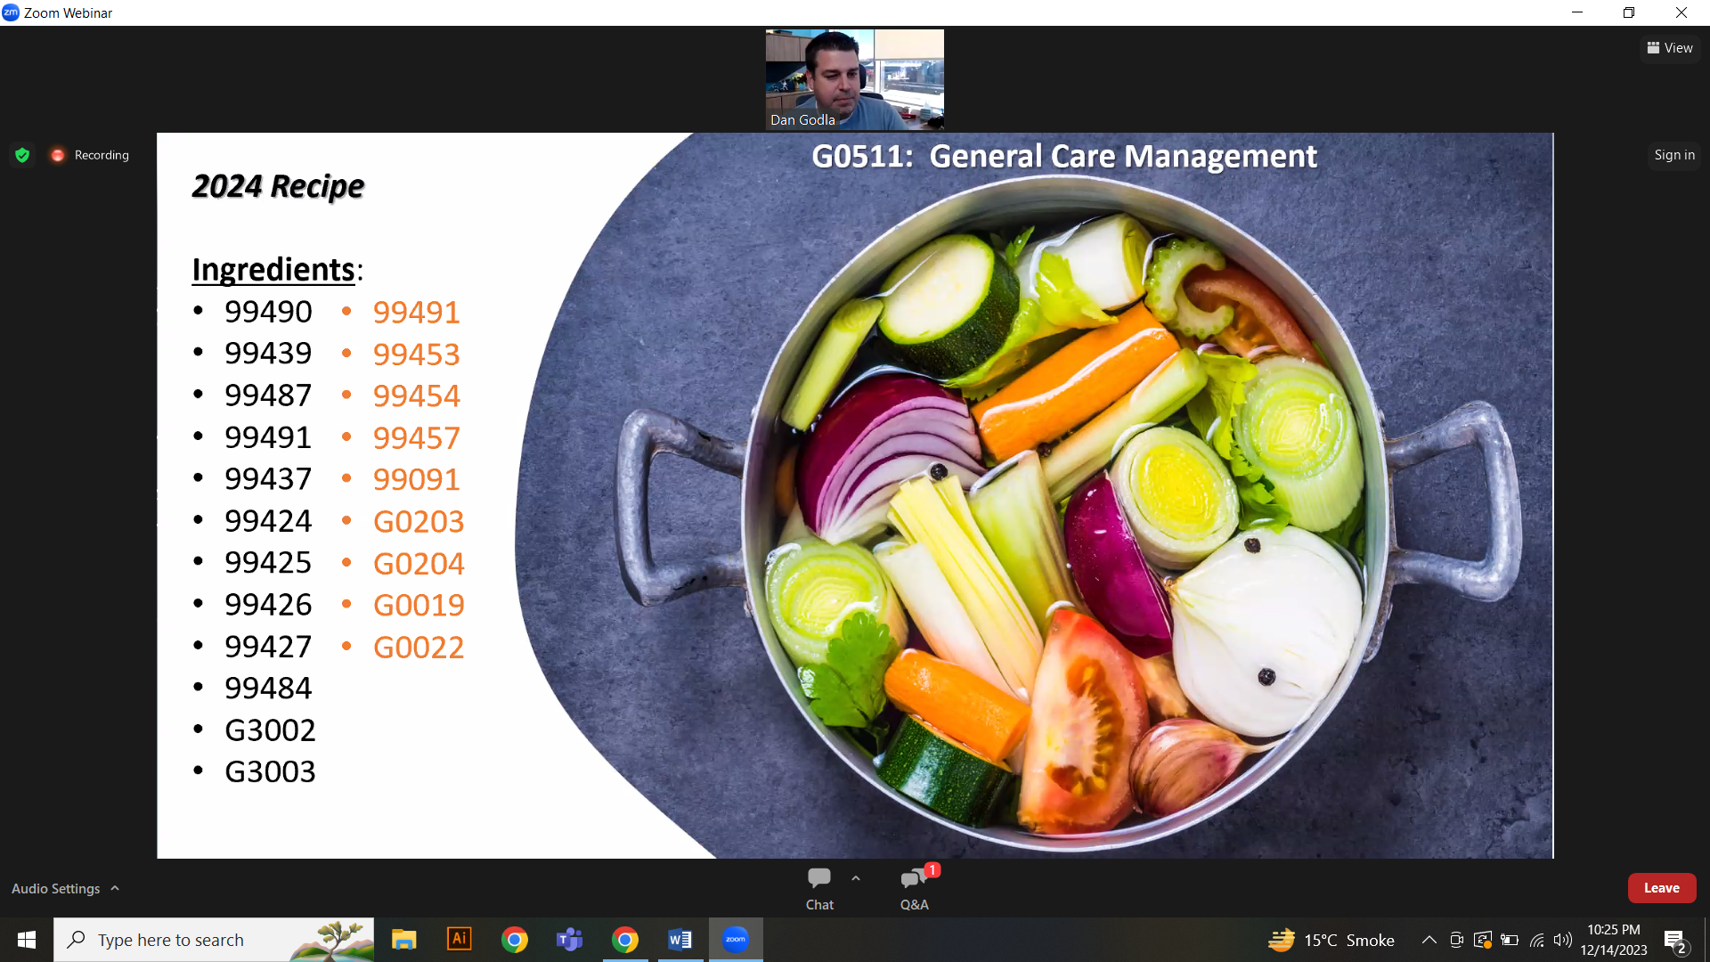

Can do a lot more things

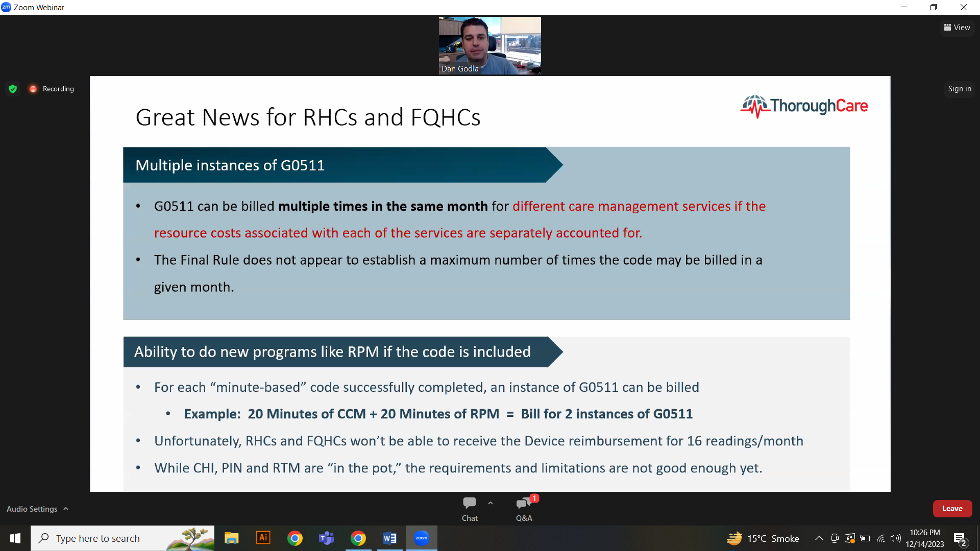

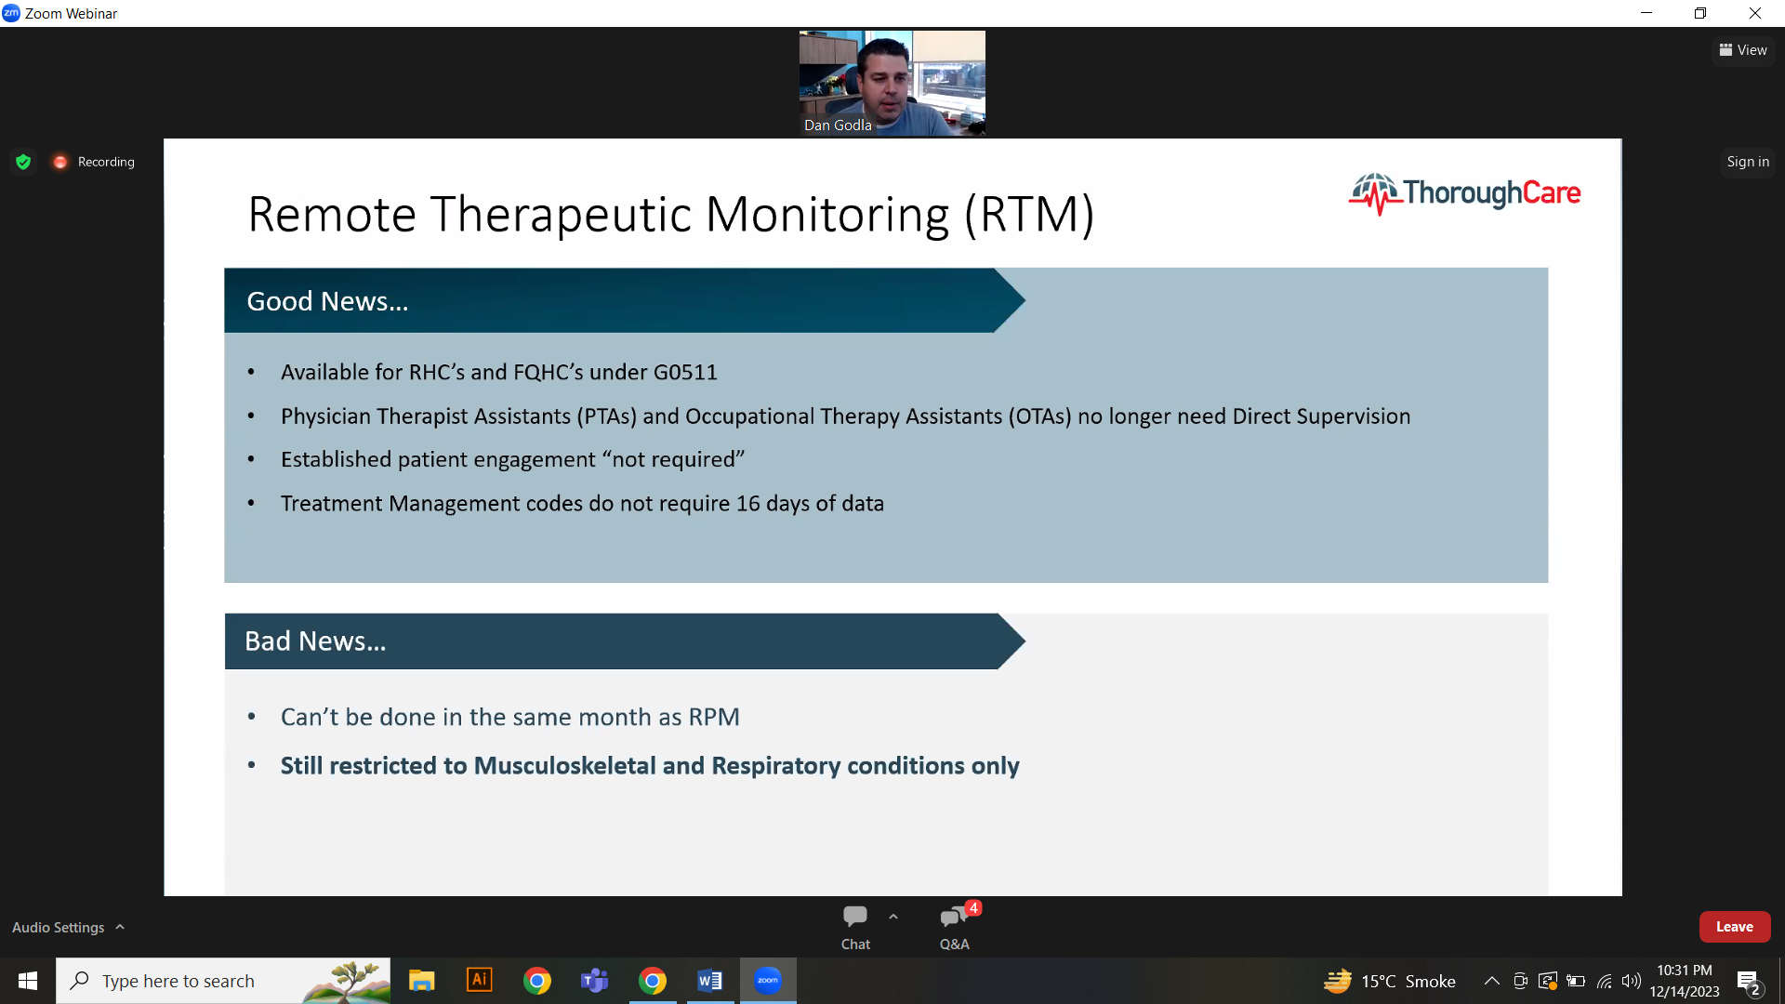

<https://www.thoroughcare.net/hubfs/videos/2024_final_rule_rhc_fqhc.mp4>